

**PREPARING FOR A DISASTER**

**A Guide for UCC Families & Friends**

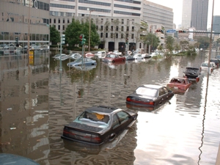

**A message to our churches:**

The Mission Statement of United Church of Christ Disaster Ministries says*, “Responding to the call of our Christ-centered faith, UCC Disaster Ministries supports holistic community recovery, worldwide, by engaging supporters, volunteers and partners to focus on preparedness, emergency relief and long-term recovery.”* This Guide supports that mission by encouraging our churches to take an active role in helping church families prepare for disaster. “If members don’t survive a disaster, neither will the church,” says David Heald, one of the Disaster Coordinators of the Florida Conference.

In a disaster, every second counts. Therefore, planning what to do before a disaster strikes provides the best protection for the families in your congregation, as well as the community. This Guide is intended to be your resource to help your family stay safe in a storm, fire, flood, tornado or hurricane.

Again, encourage your families to plan ahead and don’t be caught unaware. Help them make a family disaster plan, including a communications plan, and assemble an emergency supply kit and “Bug Out Bag.” Take time now to learn more about disasters by going to websites like <https://www.cdc.gov/disasters/index.html> and <https://www.ready.gov/prepare-for-emergencies>.

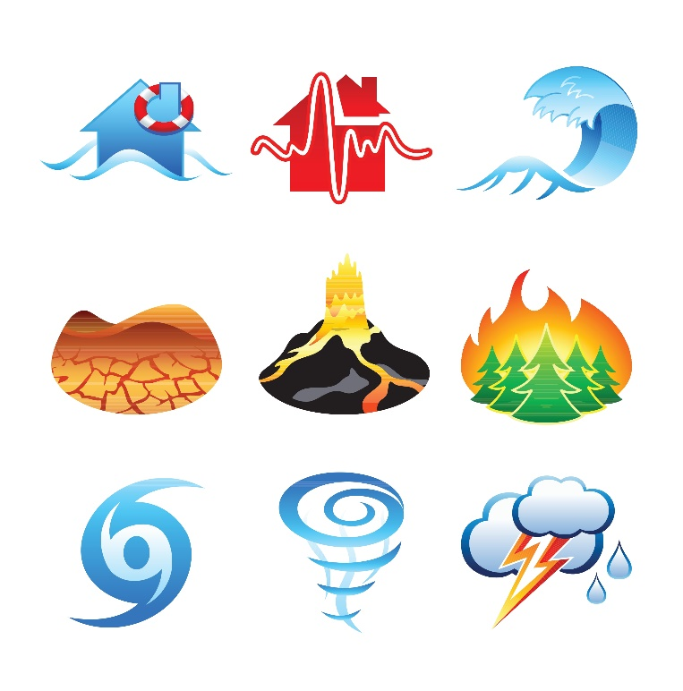**KNOW THE HAZARDS**

**Tropical Storms and Hurricanes**

A tropical storm is a rotating, organized system of clouds and thunderstorms that originates over tropical or subtropical waters and has a closed low-level circulation. Often, the most significant threat from a tropical storm or hurricane is the storm surge. (SEE BELOW)

There are four levels of tropical storms:

* Tropical Depression – Maximum sustained winds of 38 mph or less.
* Tropical Storm – Maximum sustained winds of 39-73 mph.
* Hurricane – (Category 1, 2) Maximum sustained winds of 74-110 mph.
* Major Hurricane – (Cat. 3, 4, 5) Sustained winds of 111 mph or higher.

###### Storm Watches

Tropical Storm and Hurricane Watches are issued when conditions exist for some portion of the next 48 hours.

###### Storm Warnings

Tropical Storm and Hurricane Warnings are issued when conditions are expected in some portion of the warning area within 36 hours or less.

**Storm Surge**

Storm surge is an abnormal and often dangerous rise of water levels. The flooding effects can occur suddenly and are in addition to the predicted tide or astronomical tide. According to the National Weather Service, just 6 inches of fast-moving flood water can knock over an adult; 2 feet of rushing water can displace most vehicles. Both situations present a drowning threat. Large, battering waves on top of the storm surge, and debris in the water can also pose significant threat of injury or death. Depending on a storm’s strength and the terrain, a storm surge can also flood inland areas. This widespread threat can cut off evacuation routes and make it difficult or impossible for emergency responders to reach you and provide assistance.

## Thunderstorms/Lightning

All thunderstorms produce lightning, which is a leading storm-related killer. According to the National Weather Service, lightning causes approximately 80 deaths annually and about 300 injuries per year. Most of these fatalities and injuries occur when people are caught outdoors during summer storms. Thunderstorms can produce damaging winds that exceed 100 mph, and can also spawn tornadoes and hail. However, the leading cause of death associated with thunderstorms is flash flooding, which leads to more than 140 fatalities each year, according to the National Weather Service.

## Flooding

Flooding is one of the most common natural hazards, and it can happen with little warning. Some floods develop slowly, over long periods of rainfall; others develop quickly from heavy rain. Floods may occur when rivers and streams overrun their banks or when there is an accumulation of rainwater on saturated ground and paved surfaces. Areas may also flood due to blocked drains.

Flood risk is not just based on history, but also on rainfall, topography, flood-control measures, river-flow and tidal-surge conditions, as well as changes due to land development and construction.

Driving on flooded roadways is very dangerous. Flood waters can be swift and powerful. More than half of all flood-related drownings occur when vehicles enter flooded roadways. When you see flooded roadways, remember: **Turn Around, Don’t Drown**!

Most homeowners insurance, even with a hurricane policy, does NOT cover flood damages. Flooding from rising waters requires a separate insurance policy. Contact the National Flood Insurance Program at (800) 767-4341 or visit [www.floodsmart.gov](http://www.floodsmart.gov/).

Tornadoes

Tornadoes are nature’s most violent storms. They extend from a thunderstorm to the ground with winds that can reach 300 mph. Damage paths from tornadoes can stretch several miles. While some tornadoes are clearly visible, others are obscured by rain or low-hanging clouds. Occasionally, tornadoes develop so rapidly that little, if any, advance warning is possible. Before a tornado strikes, the wind may be calm and the air may become still. Tornado danger signs include dark, often greenish sky; hail, and/or a loud roar, similar to a freight train.

Tornadoes may accompany tropical storms and hurricanes as they move inland. While there is no designated tornado season, tornadoes occur more frequently in the spring and summer months. Tornado-related deaths average 70 per year.

###### Tornado Watch

A Tornado Watch means conditions are favorable for the development of tornadoes within and close to the watch area.

###### Tornado Warning

A Tornado Warning means a storm spotter has observed a tornado or radar is indicating that a tornado is occurring or is close.

## Wildfires

Wildfires can spread quickly, igniting brush, trees, and houses. To protect your residence, the Forest Service recommends maintaining a “defensible space” – a zone free of flammable plants and debris – of at least 30 feet around your house and other structures. This means that you should remove dead branches, shrubbery and other debris. You should also mow grass regularly and prune tree limbs within the defensible space to a height of 10 to 15 feet from ground level. Otherwise, lower limbs draped with vines and debris could act as “ladder fuel” by igniting and allowing fire to reach your roof. Also, remove accumulated leaves from your roof and gutters.

If an evacuation order is given for wildfires in your area, you should leave immediately to protect yourself and your family. If you encounter smoke while driving, follow these tips:

* Slow down and use your low-beam headlights,
* If the smoke becomes so thick that you cannot see clearly enough to continue driving, pull off the roadway and stop. Turn on your emergency flashers.
* Exit the vehicle and move to a safe location away from traffic.
* Dial 911 to report the hazard.

**What is Disaster Preparedness?**

**Section 2** of this Guide is an Introduction to Disaster Preparedness. It discusses what may be important to you and how everything can change in an instant. It describes scenarios and how you can get started to prepare for a disaster.

**KNOW YOUR PLAN**

## Family Plan

* Create a **Family Plan** in **Section 3** that identifies each task and who is responsible. You will fill out the **American Red Cross Family Disaster Plan.** This plan is a basic outline of what you intend to do in the event of a disaster. It is meant to provide a means of keeping you and other family or friends informed of your plans if a disaster happens.
* When drafting your plan, consider the possibility that family members might be away from home, at work, or school.
* 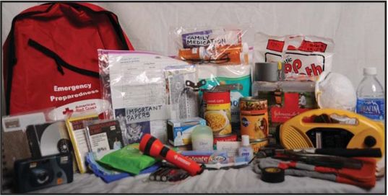Determine evacuation routes in advance. Identify a secondary route, since main routes may be congested. Create a family communications plan, which includes an emergency contact list. Include an out-of-town contact with whom you and your family you can check in.
* Determine what you will do if you are separated during an emergency.
* Create a disaster supply kit. In the **Section 4** you will find a **Disaster Preparedness Shopping List:** a list of things to shop for over an 11-week period to lessen the immediate costs of preparing for a disaster. There are two categories – Groceries and Household Supplies. There is also a list of Tips and Things To Do as well as a list of Documents you should assemble to keep ready to go.
* In **Section 5**, see the **10 Vital Items** and create a **Bug Out Bag.** This is a list of items that is designed to get you out of an emergency situation and allow you to survive self-contained for up to 3 days. FEMA is revising their recommendation to 5-7 days. You decide. It’s your survival.
* If you evacuate, take your Bug Out Bag with you. Tell friends and relatives where you are going and secure your home.
* Register those with special needs with your county Emergency Management Agency.
* **Section 6** is a handy **Disaster Supplies Checklist** provided by the County and can be placed on your refrigerator for quick reference when you complete an item.
* What are the **Best Foods to Stockpile for an Emergency**? See **Section 7** for items to Always Keep in Your Pantry.
* **Church as Shelter** is in **Section 8** ***IF*** your church can be used instead of an Approved Shelter in an emergency.

## Pet Plan

* Create a **pet preparedness kit** in an easily accessible, sturdy container.
* Preparedness kits should include: medications, medical records, proof of current shots, sturdy leashes, current photos of your pets, food, drinkable water, bowls, cat litter, Guide can opener, pet bed or toys.
* Locate the nearest pet-friendly shelter. Only household pets are allowed, such as dogs, cats, ferrets, hamsters and small rabbits at pet-friendly shelters.
* Animals must be cared for by their owners when in pet-friendly shelters. Shelter staff will not feed or clean up after pets.
* Contact hotels and motels along your planned evacuation route to check pet policies. [www.petswelcome.com](http://www.petswelcome.com/) provides pet-friendly hotel information.