An Introduction to Disaster Preparedness
Q. When you think about what is most important to you, what comes to mind? Your Church? Your Family? The home you have worked so hard to build? Many people, as they go about caring for their family and building their homes, forget the simple truth that in one moment, everything can change.
Many people don’t like to think about situations that could potentially harm their family or disrupt their lives. While considering the consequences of hurricanes, earthquakes, famine, epidemics, war and civil unrest are certainly unpleasant, it is important not to ignore such possibilities but to instead plan for them.
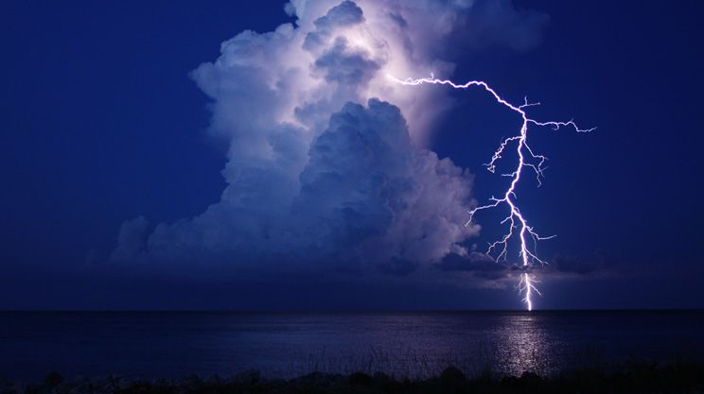
It’s not about living in fear. In fact, being prepared for such eventualities can bring about a sense of peace because you will know that, should disaster strike, you have done all that you can to be ready.

An Instant Change
Some are caught unaware by a sudden disaster or situation that immediately causes them to be in survival mode. Like a bolt of lightning, the whole world changes in the blink of an eye.
In such situations, if you have not prepared ahead of time, it can be too late.
Q. If your life were to change in an instant, would you be prepared?

!IMPORTANT NOTE!
Grocery stores only keep about two to three days’ worth of items on their shelves. When everyone is clamoring for the same emergency items at the same time, there is a good chance that you won’t get what you need. The items that will sell out first are the ones that people know will help them get through a time of crisis.

Sudden Disasters
Sudden disasters happen every day, and there is usually very little that can be done to prevent them. Catastrophes such as earthquakes, floods and tornadoes can wreak havoc on your ability to get the things that you need.

You may be left without access to water, electricity and emergency aid for days or even weeks at a time.
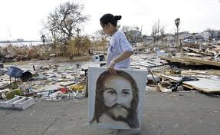
Your first line of defense when it comes to surviving a sudden disaster is preparing ahead of time.
Not All Are Sudden
While many are caught without the things that they need when a sudden disaster strikes, there is a situation that is even sadder: When people are left unprepared after a not-so-sudden disaster or situation occurs.
Sometimes, there is plenty of warning that a disaster or situation that could cause supplies to become scarce is imminent. Still, some fail to prepare. Perhaps they think that it won’t really happen or that they still have time. Whatever causes such procrastination can become problematic very quickly.
If you know that a hurricane is on the way or if there has been talk of possible civil unrest or warnings about any other situation, be sure that you have all of the items that you will need to get through the time of chaos that may follow.

Getting Started
Many people know that they should prepare for various disasters, but they don’t know where to begin, so they do nothing. One of the most important parts of survival is psychology. Improving the way you approach a survival situation, and changing the way you think about your surroundings, is an important part of the process.
For many, changing their thinking is the first step that is needed. Studies show that people who survive in difficult situations have certain traits that non-survivors do not. The good news is that most of these traits can be learned. One study found that during a crisis, 10% of people fell into a category of being a leader. They just seem to know what to do, and were able to handle the situation without becoming overly emotional or hysterical. The largest group of people, 80%, was left in disbelief at the situation. They were unsure what to do next and just sort of wandered around waiting for direction. The final 10% were those that went off of the deep end, and were completely unable to deal with the situation.
Obviously, the ideal group to be in is the leadership group. People that fall into this category are the most likely to survive. Do you need to be a natural born leader to be in this category? No. You just need to be able to keep your own fear and emotions in check and have an idea of what to do in a survival situation.
The more preparations that you make for a variety of situations, the less overwhelmed you will feel when something happens.
Start Small
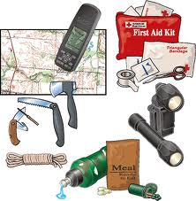
The problem that many people face when it comes to emergency preparedness and survival planning is that they do not know where to start. Others cite financial reasons for not being able to start building a stockpile of the items that they would need during an emergency.
While it would be great to be able to order every single thing that you would need all at once, very few people are in a position that allows that. Instead, start small. In fact, there are some steps that you can take that won’t cost anything at all.
Here are some small steps that you can take to get started in your emergency preparedness planning.
One of the most important things that many folks forget during a time of crisis is important paperwork. Should you need to leave your home, you will need to bring these papers along with you. Here is a list of some such important papers for you to consider.
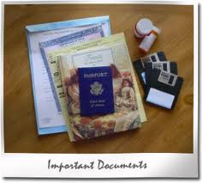
- Birth certificate
- Insurance policies
- Passport
- Social security card
- Medical records/copies of prescriptions
- Pet medical records
- Bank account information
- Deeds and titles to homes and cars
- Computer backup: This should be in the form of two memory sticks. One can be kept with you and the other should be kept in a secondary location.
Gather these documents and put them into a suitable container. Some use a safe, but remember that you need to be able to grab these items and go. For that reason, an ammunition case is a better choice. It is portable, yet still offers the needed protection for the documents.
72 Hour Emergency Kit
Another step that you can take without spending a lot of money is by assembling a short-term Sustainability Pack, also referred to as a Bug-Out Bag or a Grab ‘n Go Bag. This is a group of items that are packed and ready to go should you need to flee your home for a few days, such as to evacuate ahead of a fire or hurricane. Keep in mind that you could pack these items in a plastic bin or storage tote. You do NOT need a back pack.

Here are some items to include in your pack, bin or tote.
Be sure to provide at least 1 gallon of water per person or pet per day.
- Toilet paper
- Cleansing wipes (great item to have when a bath or shower is not available)
- Cash (small bills and change is best)
- Whistle
- Flashlight
- Extra Batteries
- Hand crank or battery operated emergency radio
- Multi-tool
- Compass
- Parachute cord (useful in building shelters)
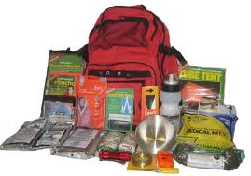
- Duct tape
- Fishing lines and lures
- Sunscreen & Insect Repellant
- Saw
- Knife
- Folding shovel
- Poncho or Rain Wear
- Gloves
- Canteen
- Knit cap
- Small first aid kit
- Glow sticks
- Matches
- Medications
- Pet food and other supply items
- Special items needed for elderly or babies
- Comfort items such as games, toys and books (Bible)

Many of the items that you may want to include in your short-term sustainability kit may be things that you already have around your home, so completing your kit will not require much of an investment.
You should keep the supplies where they are ready to go on a moment’s notice. Many keep their stuff in the trunk of their car. Keeping an extra one at home or the office is also a good idea.
See? Without spending hardly a dime you were able to check off a few important items on your emergency to-do list.
Now it is time to start assembling the food and non-food items that you will need. Again, starting small is the key. You don’t need to buy everything all at once. Instead, buy one or two extra items each time you go to the store. Before you know it, you will have built an impressive stockpile. The key is to START NOW.
Building a Stockpile on a Budget
One of the main reasons that many put off starting a stockpile is money. Already on a tight budget, some feel there is just no way to buy extra items to add to their stockpile. Keep in mind the advice from the section above: start small. Understand that it is much easier and less expensive to start building your stockpile than you might think.

Items That Will Sell Out Quickly in a Crisis
Here is a list of items that will likely fly off the store shelves in a disaster, or even the threat of a disaster. Keep in mind, this in by no means an all-inclusive list, nor is meant to scare you into rushing out to purchase these items. However, if you think about these items and how your life would be impacted without them, you may want to pick up one or two things each time you shop. Eventually, you will be prepared to Survive In Place or Get Out Of Dodge!
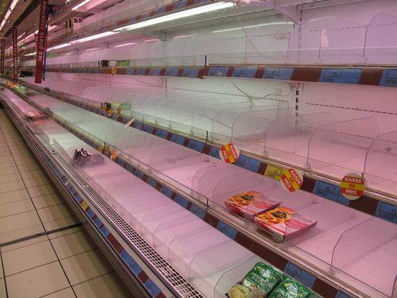
- Popcorn: Kernels have a long shelf life, they are healthy, easy to cook, and a treat for kids or adults alike. Comfort food in time of troubles.
- Salt: A staple of any meal, it’s indispensable. It has a great shelf life, and could be used to barter if needed.
- Rice: Has a variety of cooking uses and can be cooked on virtually any stove. Uncooked, it has a long shelf life.
- Cooking oil: An essential ingredient for cooking, and the only way to avoid scorching food when using a skillet.
- Outdoor stove: An outdoor cook stove is an essential part of an evacuation kit for long term survival, and could be used at home during extended power outages.
- Pots and pans: Cast iron skillets and pots are highly recommended. They don’t require rigorous cleaning to maintain. But since they are so heavy, stainless steel might be easier to pack and carry.
- Honey: It’s a great way to sweeten almost anything, and it never goes bad.
- Sugar: A supplement for all sweet foods and drinks, sugar can also be important in keeping family happy during a crisis. Like salt, it could be used for barter.
- Agave: This nectar never hardens (like honey), is low in glucose, tastes sweet and can be a good sugar or honey substitute.
- Vitamins: Depending on the food shortages your family experiences and the length of time without proper nutrition, you may need daily vitamins to supplement your diet.
- Garden seeds: If you are in a situation that prevents regular access to fresh vegetables, having a supply of non-hybrid seeds could provide a new food source, if needed.
- Milk: It is important to have a supply of condensed or powered milk for long term preparedness kits, since the Calcium found in milk is an important part of any one’s diet.
- Baking soda: You may not be cooking much during disaster situations, but having a supply of baking soda is a good and inexpensive way of extinguishing a fire.
- Powered drinks: Cocoa or juice can ease stress for everyone in a crisis, especially kids.
- Dried fruit: A variety of dried fruits is easy to store, make excellent snacks and are healthy.
- Garlic: In pill form, garlic is thought to help boost the body’s immunity. It is often used to help prevent alleviate or illness.
- Spices: Various spices are a good way of keeping meals tasting good and exciting when eating the same food items day after day. They have a long shelf life and are easy to pack in plastic bottles or plastic bags.
- Canned food: Canned soup, chicken, tuna and meats are essential for short or long term needs, and will quickly be gone off store shelves in a crisis. To add one or two items to your pantry each time you shop will easily extend your food supplies for an emergency.
- Vacuum sealer: Not many homes have this kitchen gadget, but being able to vacuum seal foods can extend the safe consumption time for perishables.
- Hand can-opener: If the power is out, even for a short time, having a hand can-opener is a lifesaver for opening your rations.
- Egg beater: Hand operated egg beaters and whisks are necessary for mixing foods when the power is off. The eggs won’t be around for long without refrigeration, but the beater and whisk will be important tools for combining and mixing ingredients.
- Beef Jerky: Next to canned meats, beef jerky is a great source of protein. It has a long shelf life and is easy to store.
- Chewing gum: Doesn’t take up much space, so it’s easy to store and helps some folks relieve stress (but don’t let my mom see me chewing it).
- Hard candy: Candy provides a quick jolt, is easy to store and can alleviate stress.
- Water containers: Collapsible containers are easy to store, but be sure to fill them up before the crisis. You may also want to consider a “Water Bob”, readily available on the internet. It fits into a standard bathtub that you can fill with clean water and not worry about what’s in the tub. It comes with a little hand pump so you can easily pump out just what you need for drinking, cooking or sanitation.
- Water Purifier: This is another item to shop for on the internet. You may never need one, but to have it and not need it is far better than to need it and not have it.
- Thermos jugs: Thermos jugs may come in handy to keep liquids hot or cold while you travel. Not so much if you shelter in place.
- Freeze dried foods and MRE’s (Meals Ready to Eat). You can find various foods and meals at camping stores and on the internet. They could be part of a solution for long term nourishment.
- Pet food: Don’t forget your furry friend. They will need to eat and drink during a crisis, just like you will.
- Toilet paper: Saved for last. You’ll never know how much you need and depend on TP until you run out. Stock up when you can, it has great shelf life, although it does take up a lot of space.

