10 Vital Items for Your Bug Out Bag

A Bug Out Bag, (also called a BOB, Get Out of Dodge Bag, GOOD, or 72-Hour Bag) is usually designed to get you out of an emergency situation and allow you to survive self-contained for up to 3 days. A lot of people plan their Bug Out Bag to sustain them for much longer than that, but there is always a limit to what you can carry on your back and a 3-day target is a good place to start. FEMA is revising their recommendation to 7 days. You decide. It’s your survival.
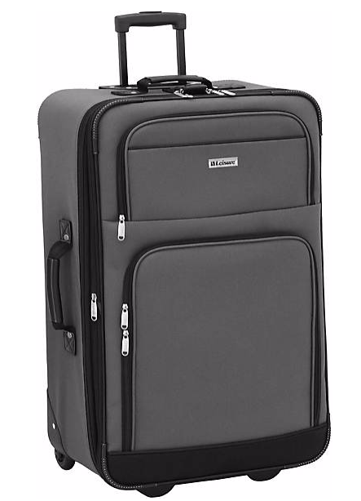
Everyone’s priorities are different, so your Top 10 list may look different than this. Which items would be in your Bug Out Bag and why?
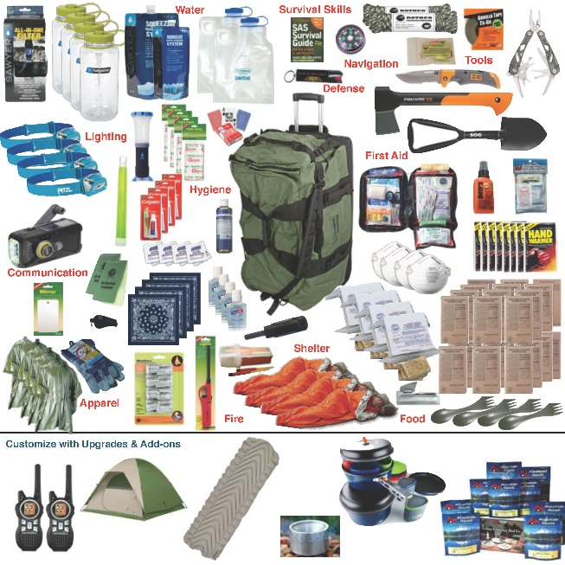

Water
It should go without saying that water is a survival basic for any situation. In a survival situation water quickly becomes the most precious commodity.
1 gallon per day per person is really the bare minimum. So your 3 day Bug Out Bag should have at least 3 gallons of water. To expand your capability or survive longer than a couple of days you will need a water purification system. This can be as simple as boiling water and iodine tablets, or a serious water filter.
- You can use a Collapsible Water Bottle for extra storage.
- Make water collection easier with a Backpacking Bucket.
- Use Coffee Filters to extend the life of your water filtration system.
- Unscented household bleach, 16 drops/gallon, sanitizes water but makes it taste like Daytona Beach water!

Food
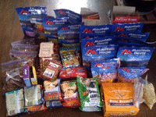
For a 3 Day Bug Out Bag Backpack Meals and Energy Bars can be sufficient. Back pack meals are freeze dried meals that you just add boiling water to. They are light weight and last a long time.
Obviously you will need a longer term food solution in any type of wide area catastrophe, but for your basic Bug Out Bag backpack meals are a good set up.

Clothing
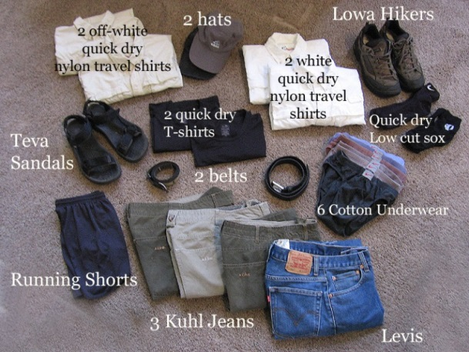
Your Bug Out Bag clothes should be similar to what you would pack for a weekend backpacking trip.
- A pair of sturdy boots or shoes
- A pair of long pants
- 2 Pairs of socks (preferably not cotton)
- 2 Shirts (Maybe 1 long sleeve and 1 short sleeve for layering)
- A Jacket that is both warm and affords protection from rain
- Warm long underwear of some kind
- A hat
- A Bandana (30 uses)
This list could go on for a while and many people would never dream of leaving their Bug Out Bag without twice that much, but in a pinch that set up could get you by for 3 days. Be sure to plan for the weather in your area: Do You have Seasonal Clothes in Your Bug Out Bag?

Shelter

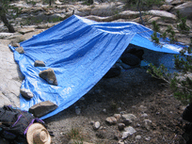
If you are going to survive for 3 days or more, you are going to need protection from the elements and a warm, dry place to sleep. You need at least:
- A Building of Last Resort or:
- Some type of tent or tarp and a way to set it up &
- A ground tarp for underneath your shelter to stay dry and a sleeping pad (Never underestimate the importance of this) and duct tape for repairs
- Some type of Bedroll, preferably a sleeping bag.

First Aid Kit
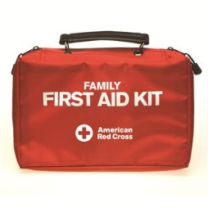
Trying to cover everything you need in your Bug Out Bag First Aid Kit is another article entirely unto itself. I won’t try to cover it because I would surely leave something out.
What I will do is recommend that you buy an American Red Cross Family 1st Aid Kit and I’d also add prescription medicines, glasses, hearing aid batteries, acetaminophen, ibuprofen, vitamins, hand sanitizer, bug repellent with DEET and sun block.

Basic Gear

Basic Gear sounds repetitive (what have I been talking about?) but it is my category for the things you absolutely cannot live without but don’t really fit well into another category. Many survivalists will not like this list because it is not exhaustive by any means, but again I will say: It will be enough to get you by for a few days.

Rain Gear – at least 2 ways to stay dry in the rain. Poncho and Jacket are good coupled with your Tent/Shelter
Fire – At least 3 different ways to make fire. With that you can get a flame but you will have to actually build the fire up, too. You’re also going to need something to cut your firewood and a knife uses too much energy long term. Choose a saw that is lightweight and easy to carry.
Cooking – Bare minimum here is a small pot/large cup to boil water in for both drinking and freeze dried meals. A small backpacking stove and fuel are better. And a can opener if you have canned goods.
Light – At least 2 dependable flashlights and a backup set of batteries for each.
Survival Knife – The most used and most versatile tool in your Bug Out Bag is your survival knife.
Dust Mask – to help filter contaminated air
Personal Sanitation – moist towelettes, garbage bags and ties

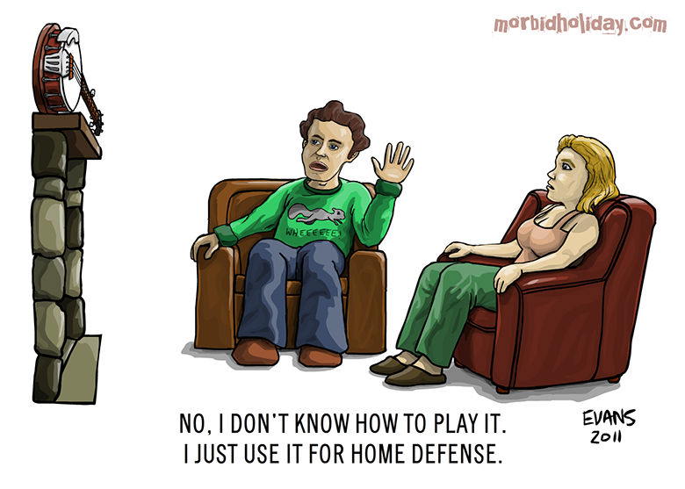
Defense
Being prepared to defend yourself is part of the survivalist mindset. Obviously, a weapon of some sort is best for this. (Though not in all situations.) I will not go into specifics about what type of weapon you should have because that is hotly debated and is really a personal choice. Take what is comfortable for you.
Your survival knife could be used for defense if you had to. Also, something as simple as a big walking stick or baseball bat can be a strong deterrent for bad guys or bad dogs – or some other desperate animal. It’s all about giving yourself options. Even the Banjo pictured above could work in a pinch!

Paperwork
A File Folder filled with important family documents (i.e. insurances, identification, bank account records), local maps, travel information, IDs and your disaster plan that includes locations of emergency centers, evacuation routes, and cell phone numbers of family members and friends. Put it all in a waterproof bag, such as a big zip-lock bag, or a waterproof ammo can. Not a bad idea to have paper, pencil, books, games and other time passers. And cash in small denominations.

Tool Kit
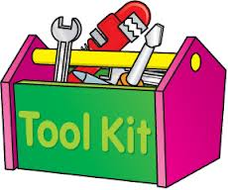
A Small Tool Kit, including a hammer and nails, screwdriver, wrench, etc. (to turn off utilities). I suggest something a lot smaller than this, and lightweight, to make it easier to carry.

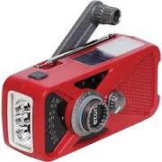
Radio

Battery or Crank-Operated Radio. In an emergency, this might be your only link to announcements regarding where aid is available and other important information, including weather alerts. Don’t forget spare batteries.

These are the Basic Needs in a survival situation. You may need more, and for a longer period of time, if the disaster recovery takes longer. Even if you don’t plan to evacuate, you would be wise to have these things at home so you can “shelter in place”.

