Clear Form

Name

Officer of the Church Evaluation

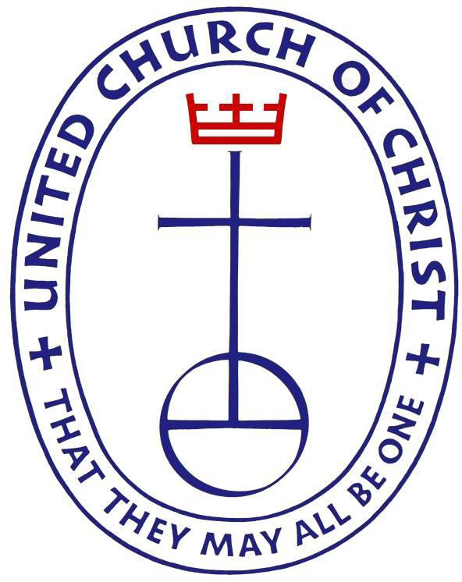

Evaluation Period: _________________________
________________________________________

INTRODUCTION

This evaluation shall be utilized for the elected Officers of the Church of the United Church .The evaluation process is separate and apart from the re-nomination process.

At its core, the performance evaluation process is about ensuring high level leadership capability. The process is designed to support the officer’s contribution to the organization by measuring skills and accomplishments and by identifying any obstacles to top performance.

The evaluation process for each Officer is a narrative 360 degree assessment. The goal of the 360 degree evaluation is to gather enough perspectives and input from persons who have worked with the Officer to provide an accurate assessment of job performance.

The following evaluators should participate in this process.

- Team Leaders and other staff considered Direct Reports
- 2 - Elected Officers
- 1 - Financial Staff Member
- 2 - Conference Ministers (Officer of the Church to select one and one appointed by Chair of CCM)
- Board Chair, Vice Chair and other Board Members as identified by the General Minister and President
- Optional – others as deemed appropriate by the General Minister and President consultation with Officer of the Church

(Optional) Provide Officer of the Church with a copy of the evaluation form and ask them to complete a self-evaluation for later discussion.
On the evaluation form read each category description, answer each question with appropriate examples and/or comments. Add additional pages as needed.
Sign and date the evaluation form.
Forward the original evaluation form to Human Resources.
1.

2.
3.
COMPLETING THE EVALUATION FORM

United Church of Christ
Officer of the Church Evaluation

Name
When answering the following questions, please identify personal knowledge or experiences you have had during the past year with the Officer of the Church.

- LEADERSHIP
- To what extent does the Officer of the Church demonstrate effectiveness and diplomacy in working with others and in maintaining productive relationships?
Enter Comments Here
- To what extent does the Officer of the Church foster teamwork and act in a manner that motivates others to high standards of fairness, consistency, enthusiasm, integrity, and accomplishment?
Enter Comments Here

- To what extent does the Officer of the Church promulgate a vision, including a specific set of goals and priorities? From your perspective, does the Officer of the Church share these goals with appropriate individuals, and have these goals been accomplished/completed?
Enter Comments Here

- To what extent does the Officer of the Church effectively require managerial supervision and accountability of the staff?
Enter Comments Here

- Overall, how would you rate your confidence in the leadership ability of the Officer of the Church?
Enter Comments Here

PROFESSIONAL KNOWLEDGE AND EXPERTISE
- To what extent does the Officer of the Church demonstrate knowledge of the responsibilities of the position and how well does he/she integrate this knowledge into the organization?
Enter Comments Here

- To what extent does the Officer of the Church foster strategic planning and goal setting?
Enter Comments Here

- To what extent does the Officer of the Church understand finance and institute sound accounting practices that assure integrity and a reasonable balance between revenues and expenses. How does the Officer of the Church demonstrate the ability to maintain yearly budgets?
Enter Comments Here

COMMUNICATION SKILLS
- To what extent does the Officer of the Church communicate clearly and persuasively in written and oral messages?
Enter Comments Here
- To what extent is the Officer of the Church an open individual who listens carefully, is respectful to others, welcomes new ideas, keeps their office door open?
Enter Comments Here

- To what extent does the Officer of the Church communicate effectively with the local churches, conferences, constituency groups, staff and Board of Directors?
Enter Comments Here

DIVERSITY
- To what extent does the Officer of the Church support the pilgrimage of being multicultural, multiracial open and affirming, accessible to all?
Enter Comments Here
- To what extent does the Officer of the Church promote fairness and equity among all employees?
Enter Comments Here

COLLABORATION
1. To what extent does the Officer of the Church provide leadership in promulgating a common vision for the Church? Overall, how would you rate the level of collegial collaboration in furthering the ministry of Christ?
Enter Comments Here

RELATIONSHIP WITH LOCAL CHURCHES AND CONSTITUENCY GROUPS AND AFFILIATED MINISTRIES
  - Give an example of the Officer of the Church promoting unity, cooperation, and harmony among UCC related groups?
Enter Comments Here

PROFESSIONAL DEVELOPMENT
1. To what extent does the Officer of the Church encourage professional & spiritual development (self & staff)?
Enter Comments Here

ADDITIONAL COMMENTS
Enter Comments Here

Signature of Evaluator Date

Print Form
Clear Form

