
Opening Worship at General Synod
Friday, June 30, 2017
2:30 pm

*indicates that all are invited to stand in body or spirit.
Congregation is invited to respond as indicated by Bold print.

Prelude Charleston Rag Sac au Lait
Memories of You
I'm Just Wild about Harry
Music of Eubie Blake, Baltimore native and Presidential Medal of Freedom recipient

*Processional When the Saints Go Marching In Sac au Lait

Verse: We are traveling in the footsteps of those who’ve gone before,
But if we stand reunited, then a new world is in store.

Choruses:
1. Oh when the saints go marching in, oh when the saints go marching in,
Oh, I want to be in that number, when the saints go marching in.

2. Oh when the sun refuse to shine, oh when the sun refuse to shine,
Oh, I want to be in that number, when the sun refuse to shine.

3. And on that Halleluyah day, and on that Halleluyah day,
Oh, I want to be in that number, on that Halleluyah day.

4. Oh when the trumpet sounds the call, oh when the trumpet sounds the call,
Oh, I want to be in that number, when the trumpet sounds the call.

Call to Worship
At the beginning, as God gave birth to creation,
light danced with darkness and her holy waters
flowed free and clear …
To make glad the city of God!

God’s rivers flowing together here,
Potomac, Susquehanna,
Rappahannock, York, and James
have fed the people and trees, animals and crops
of this land since the most ancient of times…
To make glad the city of God!

God leads us into waters of hope and liberation,
To immerse ourselves in the risks of love and justice
For all living things…
To make glad the city of God!

At the shores of all sacred waters
God calls out to the Beloved
To gather together and share abundant life:
Welcome the homeless and feed the hungry,
Embrace the stranger and seek out the outcast,
Create community with all God’s beloved…
To make glad the city of God!

Acknowledgment of Native American Territory
The history of the United States,
and of the churches taking root here,
includes the painful history of colonialism.
Undoing some of the destruction of colonialism
on the peoples native to this land and the land itself
is a spiritual, political, social challenge of this generation.

One sacred element evolving in this effort is very simple:
It is an acknowledgement of territory
and of the peoples whose land
we, as settlers, are currently occupying.

So as we gather here on the shores of the Chesapeake Bay
to worship and discern together the call of God
to the United Church of Christ for these days,
let us know that we do so on the hunting grounds and homelands
of the Susquehannock people, as well as
the northernmost members of the Piscataway Confederacy.
These people have used this land since time immemorial
and continue to do so in the present.
We offer them our gratitude and respect,
and hope in solidarity with them…
to make glad the city of God.

Let us join our voices together, to make glad the city of God!

*Opening Hymn We'll All Stand Together Amy G. Sens
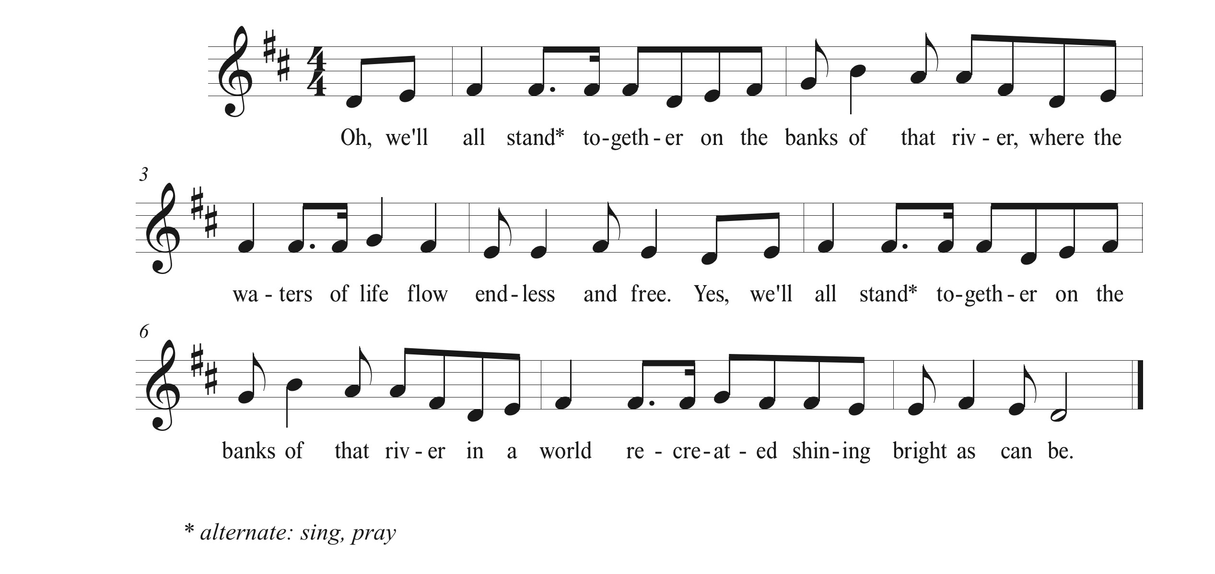
Scripture Psalm 46 Richard Bruxvoort-Colligan
Sung responsively, Cantor and Congregation

Refrain
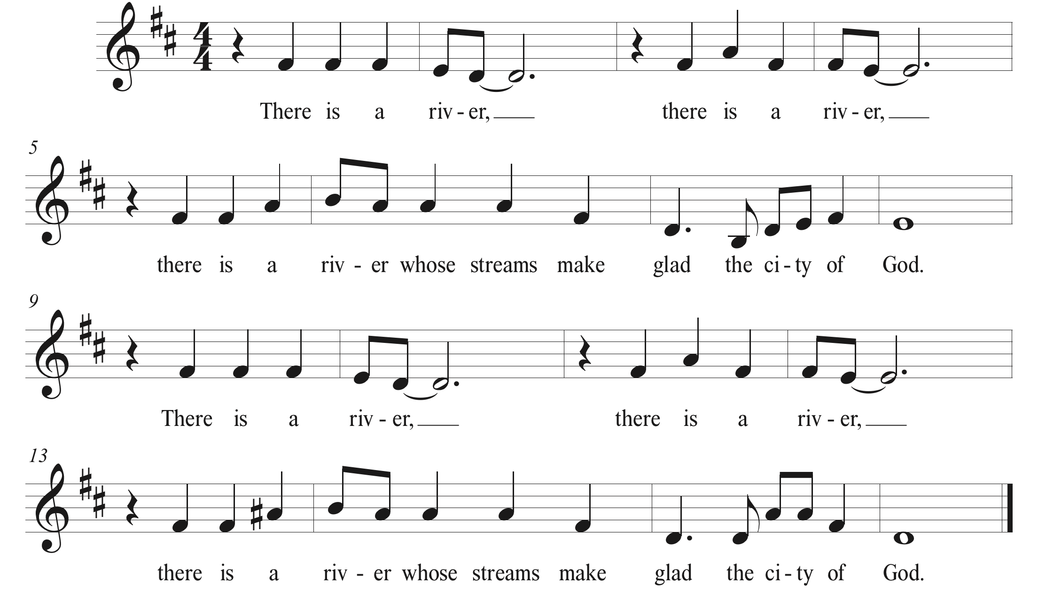

God is our refuge and strength,
a very present help in trouble.
Therefore we will not fear,
though the earth should change,
though the mountains shake in the heart of the sea;
though its waters roar and foam,
though the mountains tremble with its tumult.
Refrain
There is a river whose streams make glad the city of God,
the holy habitation of the Most High.
God is in the midst of the city; it shall not be moved;
God will help it when the morning dawns.
The nations are in an uproar, the kingdoms totter;
God thunders, the earth melts.
The GOD of hosts is with us;
the God of Jacob is our refuge.
Refrain
Come, behold the works of GOD;
see what desolations God has brought on the earth.
God makes wars cease to the end of the earth;
breaks the bow, and shatters the spear;
God burns the shields with fire.
‘Be still, and know that I am God!
I am exalted among the nations,
I am exalted in the earth.’
The GOD of hosts is with us;
the God of Jacob is our refuge.
Refrain

Sermon The Rev. Traci Blackmon
Acting Executive Minister for
Justice Witness Ministries
Offering for Ministries of the Central Atlantic Conference
The Rev. Denise Mason Bullitt
Interim Conference Minister
Central Atlantic Conference

Music at Offering Sac au Lait

Hymn Down in the River to Pray Traditional American
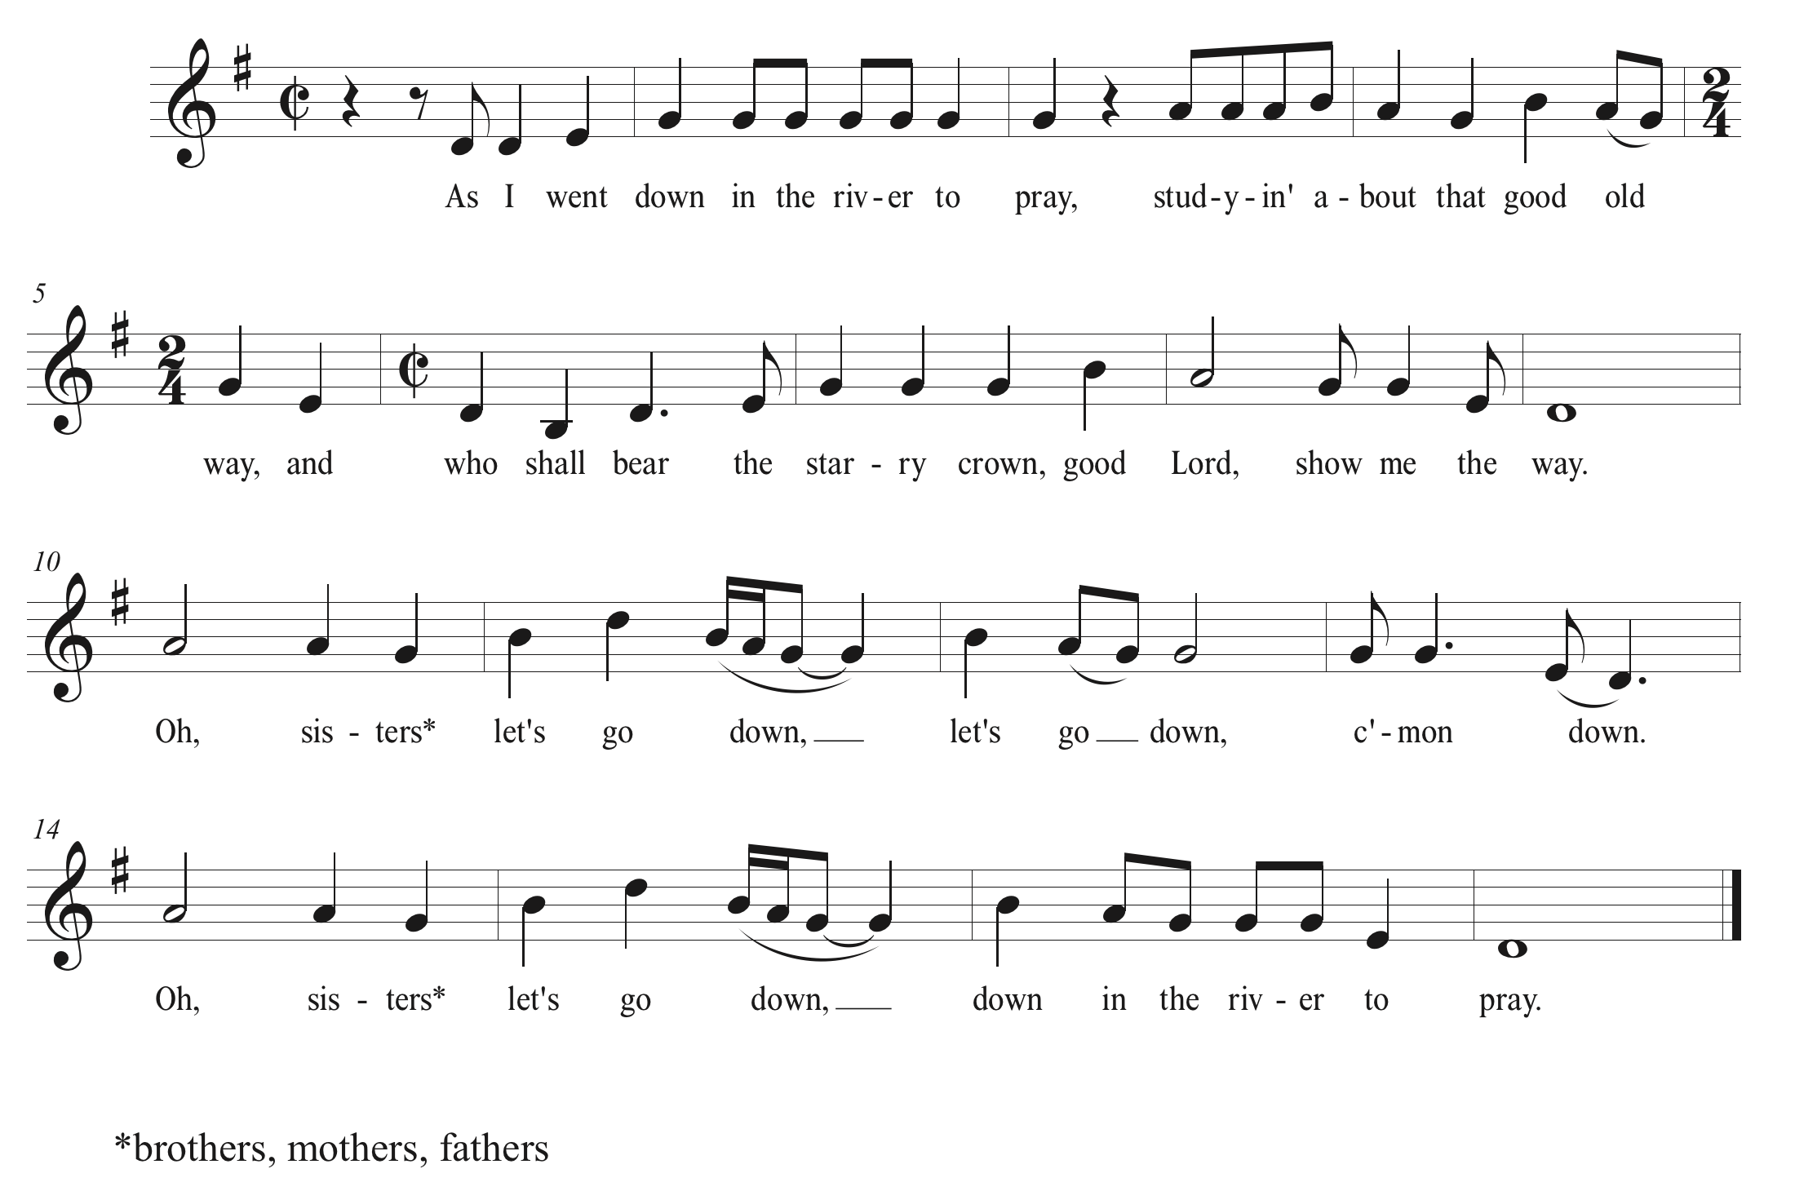
Affirmation of Baptism
Introduction
God be with you. And also with you.

Beloved of God, we belong to each other.
We affirm our relationship to Christ and each other today
through our re-affirmation of baptism.
By these waters of the Chesapeake Watershed,
Flowing through the City of Baltimore,
let us remember our baptism as
we affirm our sacred covenant with creation,
our common ancestry with all humanity, the call to justice,
and the truth that water is life.

Covenant Promises
Covenant marks our relationship with God.
As we re-affirm our baptismal vows
let us remember our responsibilities as the Body of Christ.

Will you trust in God, who has created and is creating,
who has come in Jesus, the Word made flesh, to heal and make new,
and who works in us and others by the Spirit?
We gladly will, with God’s help.
Desiring the freedom of new life in Christ,
will you seek to resist evil, and to live in love and justice?
We gladly will, with God’s help.

Will you join with your companions in this community of faith
to celebrate God’s presence, making glad the ways of God
by living with deep care for the planet, loving and serving others?
We gladly will, with God’s help.

Sharing Hopes and Dreams for the Church
We approach the waters of baptism
with radical hopes and prophetic dreams
for God’s world to be made new.

What are our hopes and dreams
for the planet which we call home?

What are our hopes and dreams for the people of this world?

What is one word that calls forth your hope and dream for the world?

Say that word silently to yourself. Say it, always,
in the language closest to your heart.

Now say that word out loud to your neighbor.

Now shout that word out loud and proud to the General Synod!

There are baskets filled with sponges throughout the space,
if one is near you, lift it up for the water blessing!
Thanksgiving over the Water
Gracious and Holy God,
We thank you, for your water is life.
Over its unshaped promise your Spirit hovered at creation.
By water, comes growth of the earth.
Through water, you led the children of Israel to freedom.
In the waters of Mary’s womb your beloved Jesus was formed.
In the muddy waters of the Jordan, Jesus was baptized
And became living water to the lowly, the oppressed, the forgotten.
Now may your Spirit be upon us and what we do,
That this water may be a sign for all of new life in Christ
in whose name we pray.

Immersed in these waters,
we become your community, Holy One,
redeemed, restored, and renewed to act in love.

Pray and Play a Blessing with Water
Pass the baskets of sponges, wet from our baptismal pool, among you.
Take one, and bless your neighbor with gladness, using its precious water!

Music

I Saw Water Flowing (Ez. 47) T.M. Scott

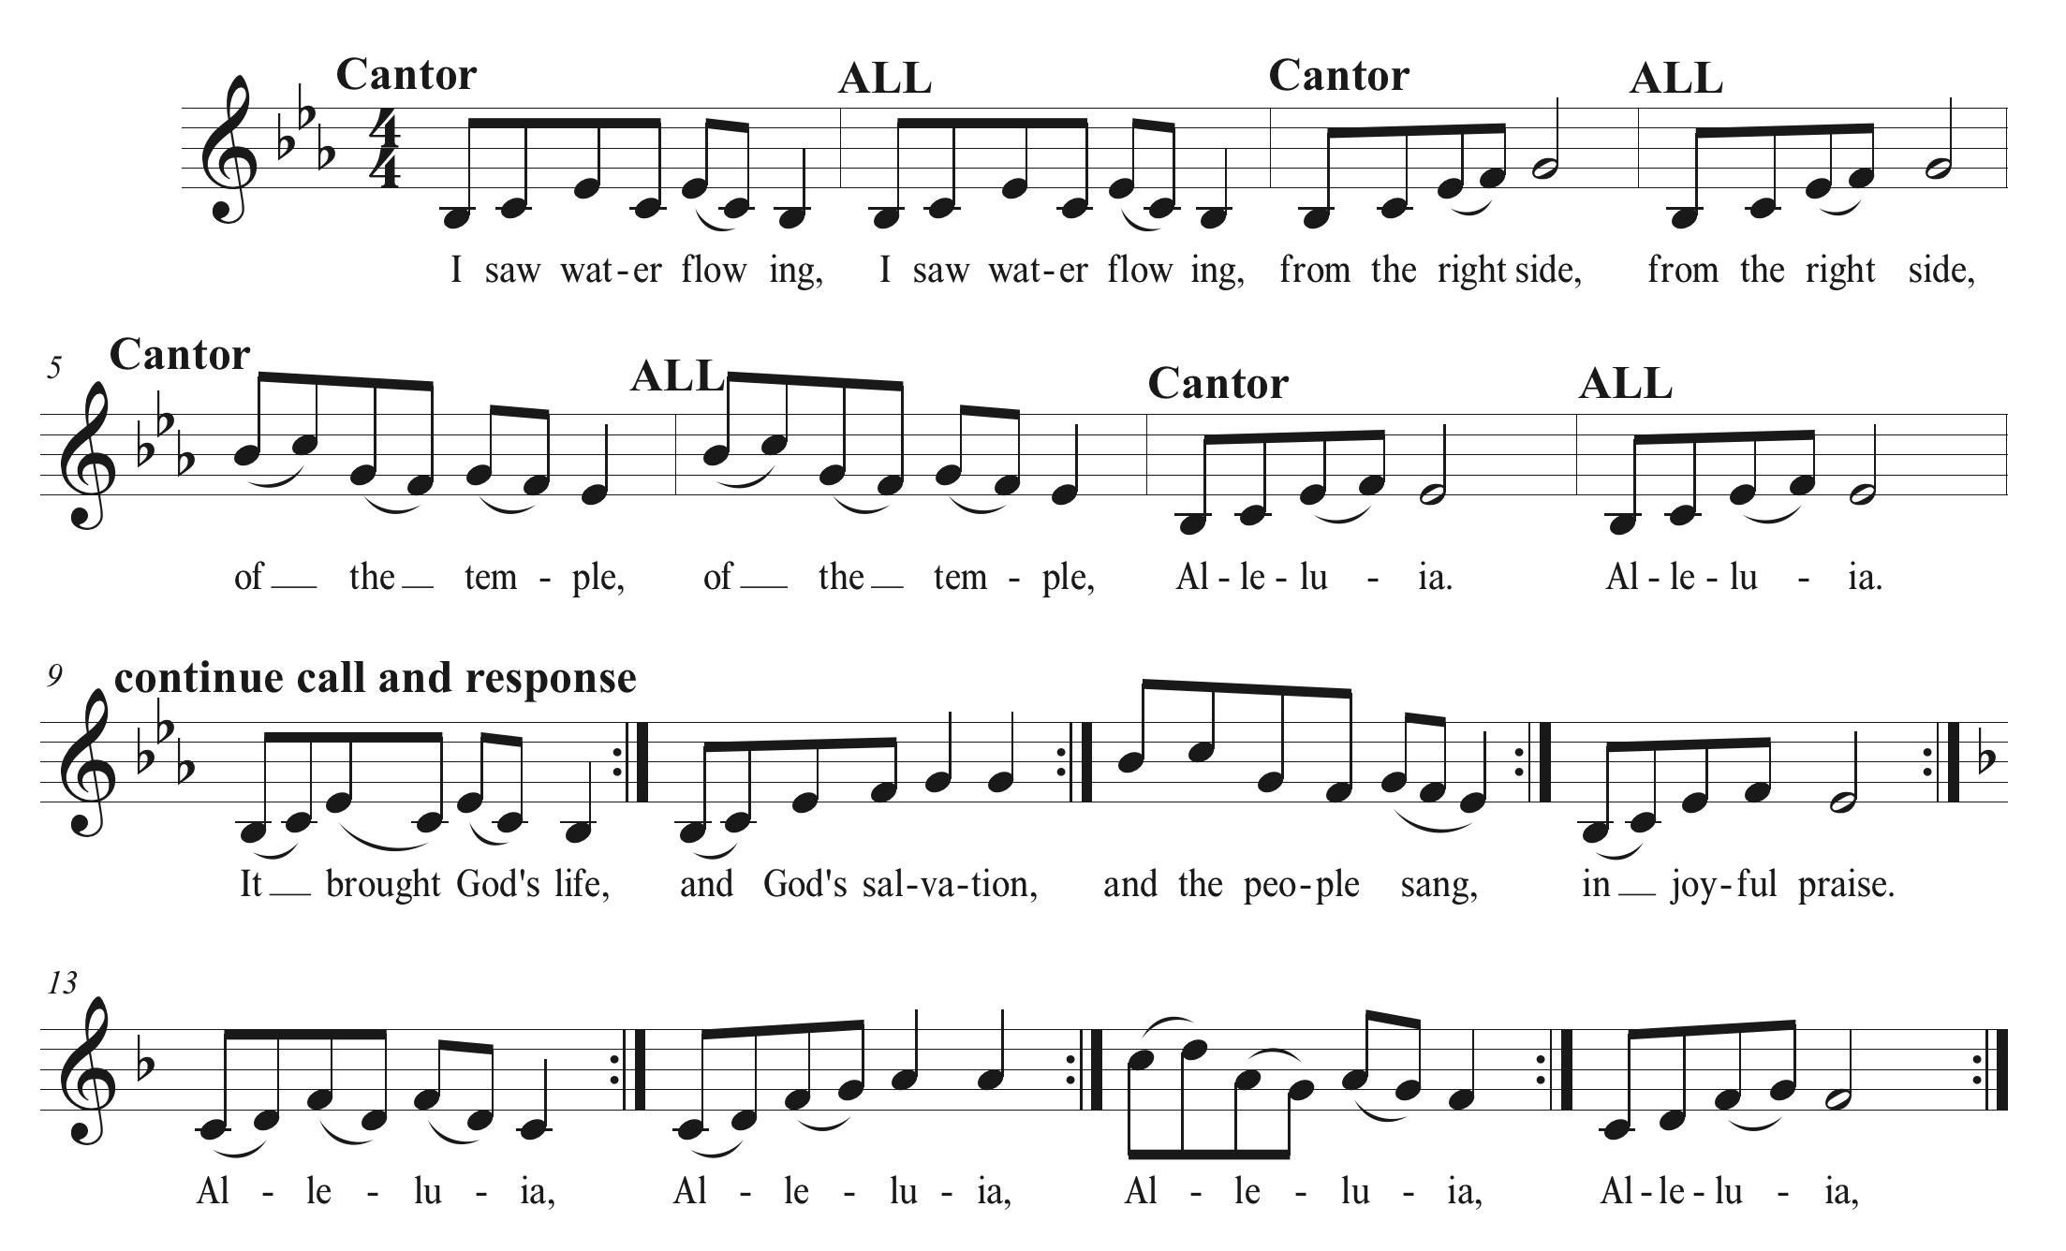

If Anybody Asks Me Who I Am Traditional Spiritual
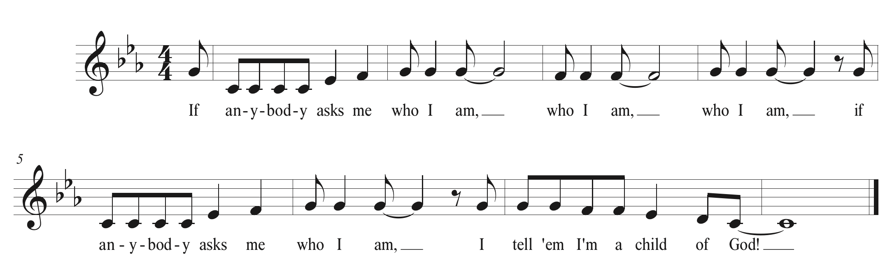

Already Done Walked Christopher Grundy 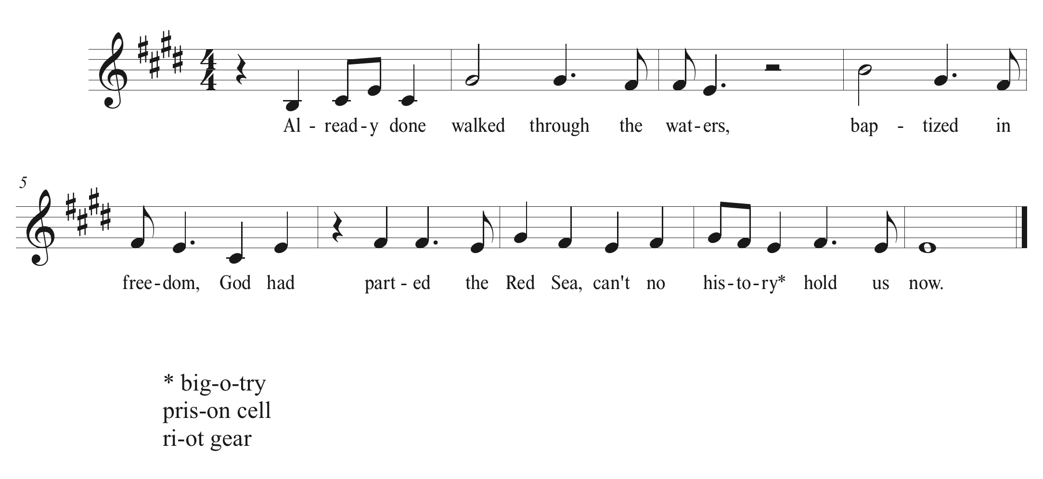Words to Bless our Going Forward: Rev. Blackmon

People of God! We have reaffirmed our baptisms!
Let us go from this font to create gladness and justice!
We are people of water and life!
Let us sing our closing hymn and get to work!

*Closing Hymn Go Make a Difference Steve Angrisano

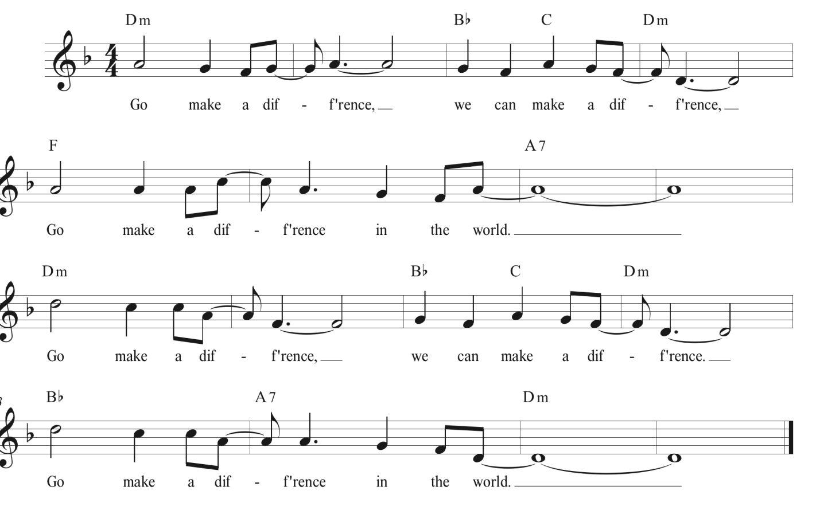
We Move into the Work of General Synod 31
Sue Artt, Moderator; Norman Williams, Assistant Moderator
Dale Bonds, Chair, United Church Board; Frank Bolden, Vice Chair, United Church Board

Gaveling Synod 31 into Session The Rev. Dr. Sue Artt
Moderator, GS 31

Acknowledgements and Thanks
Leaders in today’s service:
Preacher The Rev. Traci Blackmon, Acting Executive Minister
for Justice Witness Ministries, UCC
The Rev. John Dorhauer, General Minister and President, UCC
The Rev. James Moos, Executive Minister for Wider Church
Ministries and Co-Executive for Global Ministries, UCC
Bishop Ilsa Junkermann, who joins us to help celebrate the 500th anniversary of the Reformation. She is Deputy Bishop of the United Evangelical Lutheran Church in Germany (VELKD) and Bishop in the Evangelical Church in Central Germany (EKD). Bishop Junkermann joins us at the invitation of Global Ministries, and of the Central Atlantic Conference, with whom the churches of the EKD have a longstanding partnership.
The Rev. Dr. Sue Artt, Moderator, General Synod 31
Mr. Norman Williams, Assistant Moderator, General Synod 31
Ms. Dale Bonds, Chair, United Church of Christ Board
Mr. Frank Bolden, Vice Chair, United Church of Christ Board
The Rev. Denise Mason Bullitt, Interim Conference Minister,
Central Atlantic Conference, UCC
Ms. Jill White, Chair, Local Arrangements, Central Atlantic Conference,
Evangelical Reformed UCC, Frederick, MD
The Rev. Cindi Knox, Pastor, St. John's United Church of Christ, Evanston IL
The Rev. Freeman Palmer, Associate Conference Minister for Congregational Development, New York Conference
Ms. Lucy Adkins, member, Evangelical Reformed UCC, Frederick, MD
The Rev. Dr. Christopher Ponnuraj, Minister, The Bedford Park Congregational Church UCC, Bronx, NY; Former Moderator of national PAAM
The Rev. Ashley Goff, Pastor of Church of the Pilgrims (PCUSA), Washington, DC

Musicians and Artists:
Sac au Lait: Frank Patinella, banjo; Richard Howard, trombone; John Dierker, clarinet;
Frank Donn, trumpet; Zachary Serleth, bass; David Polimene, drums
Dr. Jo Deen (Jody) Blaine Davis, Director of Music Ministries, Congregational Church of New Canaan, CT, and President, UCC Musicians’ Association
Dr. Thomas More Scott, Director of Music Ministries, First Congregational Church, Hudson, Ohio
The Rev. Amy G. Sens, Pastor of Six:Eight UCC, Baltimore, MD
The Rev. Dr. Christopher Grundy, Associate Professor of Preaching and Worship,
Eden Theological Seminary
Mr. Edward Lawrence, Juilliard trained dancer from Trinidad who has performed and taught internationally. He has been dancing at UCC national events since 2009.
Catawba College Singers:
Jessica Yates, Joan Hedrick, Victoria Layton , Savannah Shaver, Brie Gardner
Sarah Botts , Mikaela Brown , Hannah Addair , Taylor Kroop, Mia Schuster
Dustin Chapman , Liam Pendergrass, Jason Hickerson,
Duane Leatherberry , Reshaud Brown
RJ Thornton, Angel Paez, James Satterwhite , Randall Stull , Sam Reeder

Offering: This service’s Offering will go to support the Ministries of the Central Atlantic Conference United Church of Christ, host Conference for General Synod 31. Directions for making out checks and for giving electronically are included on the Synod App.

Writer and Planners for this afternoon’s service:
The Rev. Ashley Goff, writer, Pastor of Church of the Pilgrims (PCUSA), Washington, DC
The Rev. Dr. Diane M. Carter, Pastor of St. Paul’s UCC, Bellevue, Ohio
Mr. Jerry King, Director of Television and Media at Cathedral of Hope, Dallas, Texas
Dr. Thomas More Scott, Director of Music Ministries at
First Congregational Church, Hudson, Ohio
The Rev. Susan A. Blain, Minister for Faith Formation: Curator for Worship and
Liturgical Arts, UCC
Thanks to C. Joseph Genetin-Pilawa, Assistant Professor of U.S. History, George Mason University, Fairfax, Virginia, who offered guidance concerning the Acknowledgement of Native American Territory.

Thanks to the Steinway Piano Gallery of Washington DC (11611 Old Georgetown Road , North Bethesda, MD 20852, 301-230-6535) for the loan of the Allen Organ and Steinway Piano used throughout Synod.

Artesian Pool and Fountain created by Clifford F. Dupill of The Athena Garden, Latrobe, PA.

Copyright and Licensing:
Music livestreamed under Worshipcast License 7631
Music performances covered under PERFORMmusic License 7631
Charleston Rag – Eubie Blake. Public domain
Memories of You- Eubie Blake. Public domain
I’m Just Wild about Harry – Eubie Blake. Public domain
When the Saints Go Marching In – Traditional
We’ll All Stand Together – Amy G. Sens. © 2017 Amy Sens. Used with permission of composer
There is a River: Refrain – Richard Bruxvoort-Colligan. © 2007 Augsburg Fortress Publishing. All rights reserved. Used with permission under OneLicense A-719582
Down in the River to Pray – Traditional American
I Saw Water Flowing – Thomas M. Scott. © 2001 Robertson Music. Used with permission of composer
If Anybody Asks Me Who I Am – Traditional Spiritual
Already Done Walked – Christopher Grundy. © 2016 Hand and Soil. Used with permission of composer
Go Make a Difference – Steve Angrisano. © 1997, Steve Angrisano and Tom Tomaszek. Published by OCP Publications. All rights reserved. Used with permission under OneLicense A-719582
Scripture translation: Psalm 46 NRSV adapted
Wording for Baptismal Covenant Renewal and Thanksgiving Over the Water was inspired by Baptism Services in the United Church of Christ and the United Church of Canada: Book of Worship, reprint © 2012, Local Church Ministries UCC and “The Covenant of Baptism: Prayer of Thanksgiving and the Pouring of Water” from Celebrate God’s Presence: A Book of Services for The United Church of Canada. The United Church Publishing House, 2000. P. 342, 15Ob002. Used with permission

