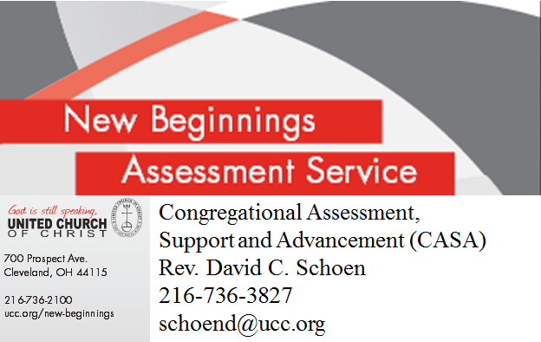 Regional Judicatory Role in New Beginnings

New Beginnings Assessment Service is a collaborative partnership between congregation(s),
Conference or Region, UCC Congregational Assessment, Support and Advancement Ministry (CASA), and DOC HOPE Partnership.

The following is an overview of the judicatory role in New Beginnings, noting that this doesn’t have to ALL be on the shoulders of Conference Staff. Some regions/conferences have had success in appointing a “New Beginnings Coordinator” who is sometimes a retired pastor or other leader who can help shepherd churches through this process.

The regional/area minister’s office is asked to:
- Host a “New Beginnings Come and See” presentation and invite church leaders to attend. This two hour (no cost) workshop is presented by a CASA/HOPE Partnership colleague, and generally held at a local church that is within 2-hours driving distance of the invited churches. The regional/area minister invites pastors and up to 8-10 lay leaders to attend. (We’ve found that the more lay leaders attend, the greater the likelihood that a church will sign-on.) At the event, the regional pastor offers a welcome and then participates in the conversation as much as he or she wishes. Church leaders will receive NB applications and are given about 30-days to decide for their participation in a NB cluster. (Although any church can apply singularly for NB, the cost is $1,000 cheaper for those that “cluster” together so the service can be provided with lower travel costs.) See next page for a sample invitation you might send to church leaders.

- Follow-up with the congregations who attend the Come and See and any other churches that have shown interest but were unable to attend. The regional minister can send an application and brochure and point out the New Beginnings website: www.ucc.org/new-beginnings . Often, a follow-up call from a regional pastor can help the church make a decision for NB.

- As the NB deadline for applications approaches (typically 30-days after the “Come and See”), conference staff will contact David Schoen to let him know who has applied. Dave will contact Matt Rosine in HOPE Partnership to begin scheduling the Assessment visits. Often, it takes a little patience and “calendar juggling” to schedule the assessment visits on a date that is acceptable to the regional office, the church and the assessor. HOPE will try to schedule all assessments on consecutive days (if possible), to reduce assessor travel costs.

- Attend the evening portion of the Assessment visit for each church. Each church will be visited by a HOPE Assessor for a one-day visit from roughly 3-9pm. We ask the regional partner to join this session from 5:30 to 8:30pm. Sometimes, if the regional minister cannot attend all assessments, another pastor in the region is asked to help. At 7:00pm, the regional partner facilitates an “Appreciative Inquiry” session for 10-25 congregational leaders. (An outline for this session is attached.) This session takes place at the church from 7:00- 8:30pm. In addition, the regional partner is invited to attend a dinner meeting (5:30 – 6:45pm) at a nearby restaurant. The purpose of this dinner is for 3-4 church leaders to join the pastor and consultant for a conversation about issues facing the church (history, conflict, future plans, etc). Since this dinner is held at a nearby restaurant, it’s good for the regional partner to contact the church earlier in the day to confirm the location for the dinner. This is usually not known until the day of the assessment.

- The regional partner also coordinates the Cluster Event (a follow-up retreat for 7-12 leaders from each church in the cluster). This Cluster Event is usually held about 8 weeks after the assessment visits are completed. We ask the regional partner to make arrangements in a centrally-located church for the two-day event. Typically, this event is held on a Friday evening and Saturday morning. The regional partner schedules use of the church and makes arrangements for a Friday meal and Saturday lunch. If there are costs incurred, the regional minister typically advises churches to pay a per-person fee to reimburse any expenses. Often times, the host church agrees to fix meals at no cost.

The content and materials for this training event are provided by Hope Partnership consultants; however, the regional/conference staff person is invited to offer a brief devotional/worship event at the close of each day’s presentation. A more detailed schedule for this event will be sent to the region prior to the event.

***In the event that only ONE congregation is going through New Beginnings in the region, this event is usually scheduled for two consecutive weeknights, instead of over a weekend.

- Finally, the regional minister stays in touch with the New Beginnings congregations, offering support, prayer and (sometimes) additional visits. Sometime, churches need some encouragement for making a tough decision like selling their facility or starting a new church. While HOPE Partnership can help with the practical next steps for these decisions, often a church needs someone “local” who can be available to attend a special board meeting or worship service. CASA/HOPE Partnerships also stays in touch with the churches, often bringing together a conference call 6-9 months after the Cluster Event.

SAMPLE INVITATION TO SEND TO CHURCH LEADERS, INVITING THEM TO A “COME AND SEE” – PLEASE SEND TO CHURCHES WITH A COPY OF THE “NEW BEGINNINGS” BROCHURE:

Does your church feel stuck in “neutral”? Are church offerings going down while costs keep going up?

You and other members of your church are invited to “Come and See” about the New Beginnings Assessment Service. On ____date______, our region is hosting a conversation with Rev. David Schoen from our United Church of Christ ministry of Congregational Assessment, Support and Advancement.

New Beginnings is an opportunity for your church to assess your options for ministry and make bold decisions for the future. Over 150 churches nationwide have found help with New Beginnings. While many congregations face tough questions about their survival and sustainability, many are also finding courage and support as they initiate a New Beginning. You can read more about this opportunity in the enclosed brochure and by visiting www.ucc.org/new-beginnings.

You and others from your church are invited to join David at the “Come and See” event at __time__ on __date___. The event will be held at __location___. So we can prepare for your church, please notify (conference contact at (email address) or (telephone #) to RSVP on behalf of your church. If you are interested but unable to attend, please let (conference contact) know of your congregation’s interest.

This event requires no cost or commitment on your part - it is a time to "come and see" if this might be something good for your church! The consultations will be scheduled to take place later this year. While there is a consultation fee for this program, CASA/HOPE Partnership and/or (your conference name) can also help with fundraising to make this service more affordable for your congregation.

We are looking forward to several congregations in our region participating in this New Beginnings cluster. I hope your church will consider this important opportunity!

